EXP NO: 04 SAMPLING AND EFFECT OF ALAISING
DATE: 31/07/2025

AIM:
To generate and plot the sampling of sinusoidal signal by using MATLAB.

SOFTWARE REQUIRED:
MATLAB software.

THEORY:
SAMPLING THEOREM:
A continuous time signal can be represented in its samples and can be recovered back when sampling frequency fs is greater than or equal to the twice the highest frequency component of message signal
f s ≥ 2fm
ALAISING:
In signal processing, aliasing is an effect that cause different signals to become indistinguishable (or aliases of one another) when sampled. It also refers to the distortion or artifact that results when the signal reconstructed from samples is different from the original continuous signal.

OUTPUT:
FIGURE_1
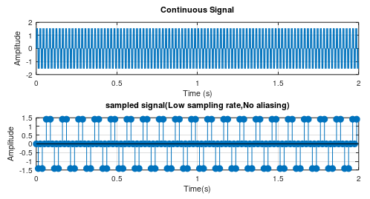

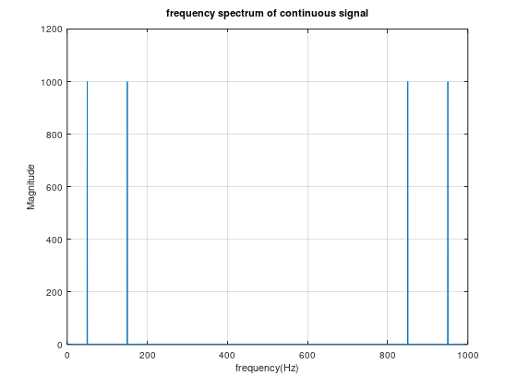
FIGURE_2
MAT LAB CODE FOR SAMPLING AND ALAISING:
Fs_continuous = 1000;
T = 1 / Fs_continuous;
L = 2;
t_continuous = 0:T:(L-T);
f1 = 50;
f2 = 150;
x_continuous = sin(2*pi*f1*t_continuous) + sin(2*pi*f2*t_continuous);

figure;
subplot(3, 1, 1);
plot(t_continuous, x_continuous);
title('Continuous Signal');
xlabel('Time (s)');
ylabel('Amplitude');
grid on;

Fs_low = 80;
Fs_high = 300;
t_low = 0:1/Fs_low:(L-1/Fs_low);
t_high = 0:1/Fs_high:(L-1/Fs_high);
x_low = sin(2 * pi * f1 * t_low) + sin(2 * pi * f2 * t_low);
x_high=sin(2 * pi* f1 * t_high) + sin(2 * pi * f2 * t_high);
subplot(3,1,2);
stem(t_low,x_low,'filled');
title('sampled signal(Low sampling rate,No aliasing)');
xlabel('Time(s)');
ylabel('Amplitude');
grid on;

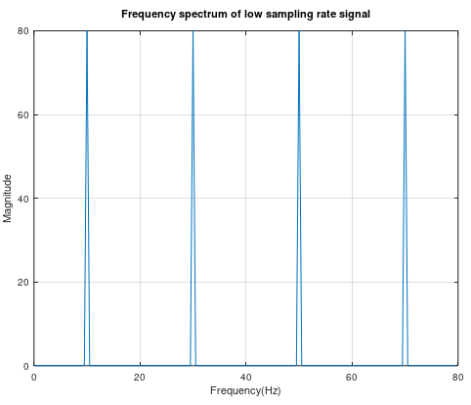
FIGURE_3

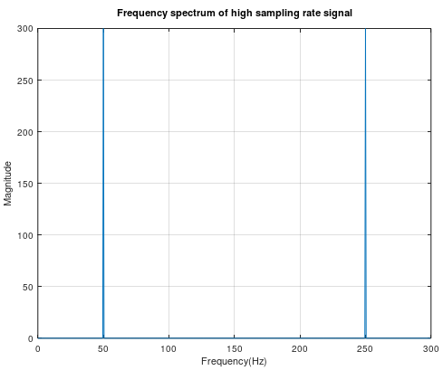
FIGURE_4

N=length(t_continuous);
Y_cont=fft(x_continuous);
f_cont=(0:N-1)*(Fs_continuous/N);
figure;
plot(f_cont,abs(Y_cont));
title('frequency spectrum of continuous signal');
xlabel('frequency(Hz)');
ylabel('Magnitude');
grid on;

N_low=length(t_low);
Y_low=fft(x_low,N_low);
f_low=(0:N_low-1)*(Fs_low/N_low);
figure;
plot(f_low,abs(Y_low));
title('Frequency spectrum of low sampling rate signal');
xlabel('Frequency(Hz)');
ylabel('Magnitude');
grid on;

N_high=length(t_high);
Y_high=fft(x_high,N_high);
f_high=(0:N_high-1)*(Fs_high/N_high);
figure;
plot(f_high,abs(Y_high));
title('Frequency spectrum of high sampling rate signal');
xlabel('Frequency(Hz)');
ylabel('Magnitude');
grid on;

INFERENCE:

CONTENTS | MARKS AWAREDED | MARKS OBTAINED
PREPARATION | 40
OBSERVATION | 30
RECORD | 20
VIVA VOCE | 10
TOTAL | 100

RESULT:
Thus, the program for sampling and aliasing of sinusoidal signal was executed and the output was verified using MATLAB.

EXP NO: 05 SPECTRUM ANALYSIS USING FFT OF SIGNAL
DATE: 07/08/2025

AIM:
To perform the spectrum of signal using FFT and plot the signal using MATLAB.

APPARATUS REQUIRED:
MATLAB Software.

THEORY:
The Fast Fourier Transform is an algorithm optimization of the DFT—Discrete Fourier Transform. The “discrete” part just means that it’s an adaptation of the Fourier Transform, a continuous process for the analog world, to make it suitable for the sampled digital world. The FFT or Fast Fourier Transform spectrum analyzer is now a form of RF spectrum analyzer that is being used increasingly to improve performance reduce costs.
As the name suggests the FFT spectrum analyzer is an item of RF test equipment that uses Fourier analysis and digital signal processing techniques to provide spectrum analysis. Using Fourier analysis any waveform in the time domain can be represented by the weighted sum of sine and cosine signals. Using this concept, the FFT spectrum analyzer samples the input signal. It then computes the magnitude of its sine and cosine components of the overall signal, and finally it displays the spectrum of the signal.

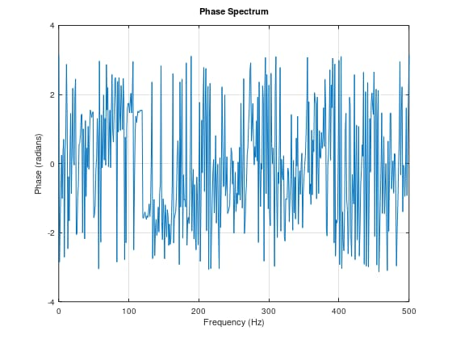
OUTPUT:

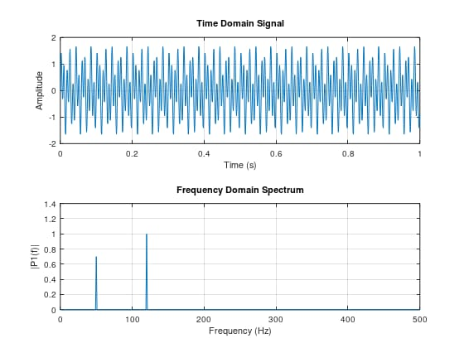
MAT LAB CODE FOR SPECTRUM ANALYSIS USING FFT
Fs = 1000;
T = 1 / Fs;
L = 1000;
t = (0:L-1) * T;
f1 = 50;
f2 = 120;
x = 0.7 * sin(2 * pi * f1 * t) + sin(2 * pi * f2 * t);
X = fft(x);
P2 = abs(X / L);
P1 = P2(1:L/2+1);
P1(2:end-1) = 2 * P1(2:end-1);
f = Fs * (0:(L/2)) / L;
figure;
subplot(2, 1, 1);
plot(t, x);
title('Time Domain Signal');
xlabel('Time (s)');
ylabel('Amplitude');
grid on;

subplot(2, 1, 2);
plot(f, P1);
title('Frequency Domain Spectrum');
xlabel('Frequency (Hz)');
ylabel('|P1(f)|');
grid on;

figure;
phase = angle(X(1:L/2+1));
plot(f, phase);
title('Phase Spectrum');
xlabel('Frequency (Hz)');
ylabel('Phase (radians)');
grid on;

INFERENCE:

CONTENTS | MARKS AWAREDED | MARKS OBTAINED
PREPARATION | 40
OBSERVATION | 30
RECORD | 20
VIVA VOCE | 10
TOTAL | 100

RESULT:
Thus, the program for spectrum analysis of FFT signal was executed and the output was verified using MATLAB software.

EXP NO: 06 CALCULATION OF FFT OF A SIGNAL
DATE: 14/08/2025

AIM:
To calculate the FFT of a signal by using MATLAB software.

APPARATUS REQUIRED:
MATLAB Software.

THEORY:
FAST FOURIER TRANSFORM:
A fast fourier transform(FFT) is an algorithm that calculates the discrete fourier transform (DFT) of some sequence. The DFT is a tool to convert specific types of function into other types of representations. Another way to explain DFT is that it transforms a structure of a cycle of a waveform into sine components.

OUTPUT:
Input signal :
- 1 2 3
FFT of the signal :
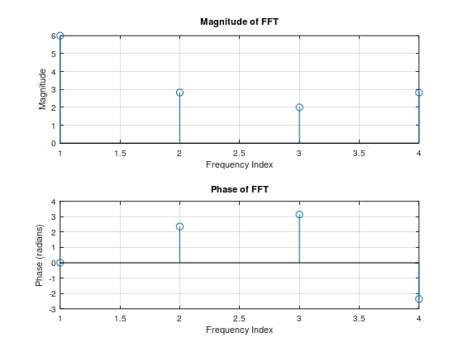
6+0i -2+2i -2+0i -2-2i

MAT LAB CODE FOR CALCULATION OF FFT
x = [0,1, 2, 3];
X = fft(x);
disp('Input Signal:');
disp(x);
disp('FFT of the Signal:');
disp(X);

figure;
subplot(2, 1, 1);
stem(abs(X));
title('Magnitude of FFT');
xlabel('Frequency Index');
ylabel('Magnitude');
grid on;

subplot(2, 1, 2);
stem(angle(X));
title('Phase of FFT');
xlabel('Frequency Index');
ylabel('Phase (radians)');
grid on;

INFERENCE:

CONTENTS | MARKS AWAREDED | MARKS OBTAINED
PREPARATION | 40
OBSERVATION | 30
RECORD | 20
VIVA VOCE | 10
TOTAL | 100

RESULT:
Thus, the program for calculation of FFT of a signal is executed and the output is verified using MATLAB software.

